**12. Working on the Marist Mainframe**

**12.1 Allocating Your Assignment PDSE**

**12.2 Editing in ISPF**

**12.3 Submitting and Viewing Results in ISPF**

**12.4 Using mar_ftp.exe to Download Marist Output**

**12.5 Using FileZilla to Download Marist Output**

**12.6 Transferring Files to Marist**

**12.7 How to Fix Invalid Characters Found in ISPF**

**12.8 Customizing TSO/ISPF**

**12.1 Allocating Your Assignment PDSE**

To program on the mainframe, it is necessary to first create, or allocate, a data set known as a partitioned data set extended (PDSE) where your code will be stored. What follows are the steps necessary to allocate your assignment PDSE that you will use all semester. During the first week of class, your instructor will show you how to back up this important data set so that you have something to go back to if you delete it.

First, download a copy of Tom Brennan's Vista TN3270 at:

<http://www.tombrennansoftware.com/download.html>

For those of you wishing to use Adobe's *Source Code Pro* fonts, download the V2.00 Preliminary Test Version at:

[http://www.tombrennansoftware .com/v200/](http://www.tombrennansoftware.com/v200/)

With either version, you will have to use the current Vista TN3270 registration name and code so that your copy will not expire after the software's trial period. This can be found in Blackboard's Course Documents.

Each time run Vista TN3270, you will be presented the following:

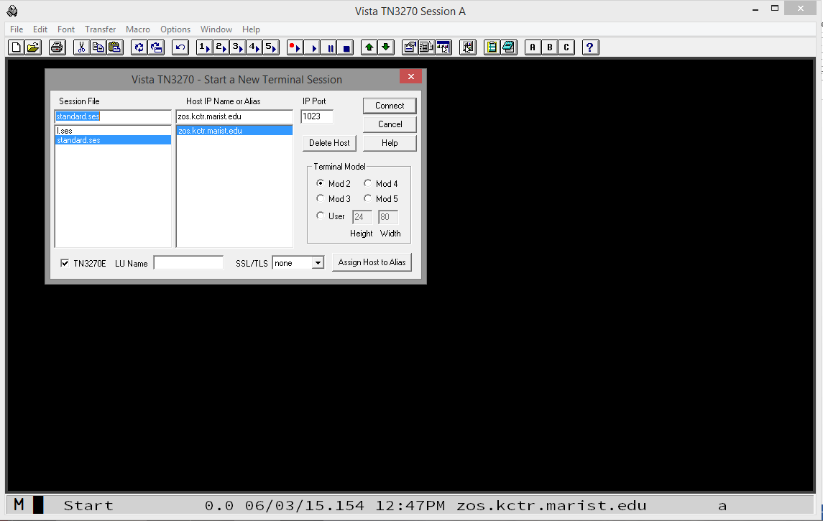

To connect, enter Host IP Name zos.kctr.marist.edu and Port 1023 and click Connect. You will be presented the following:

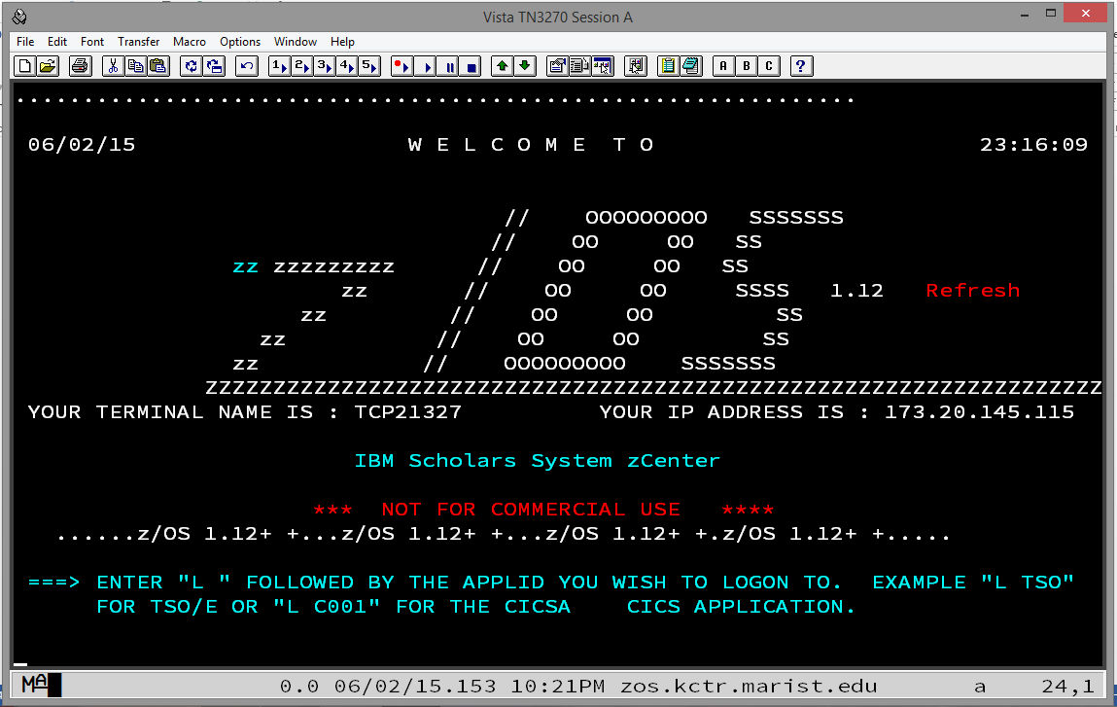

Type the letter L and press Enter. You will be presented the following:

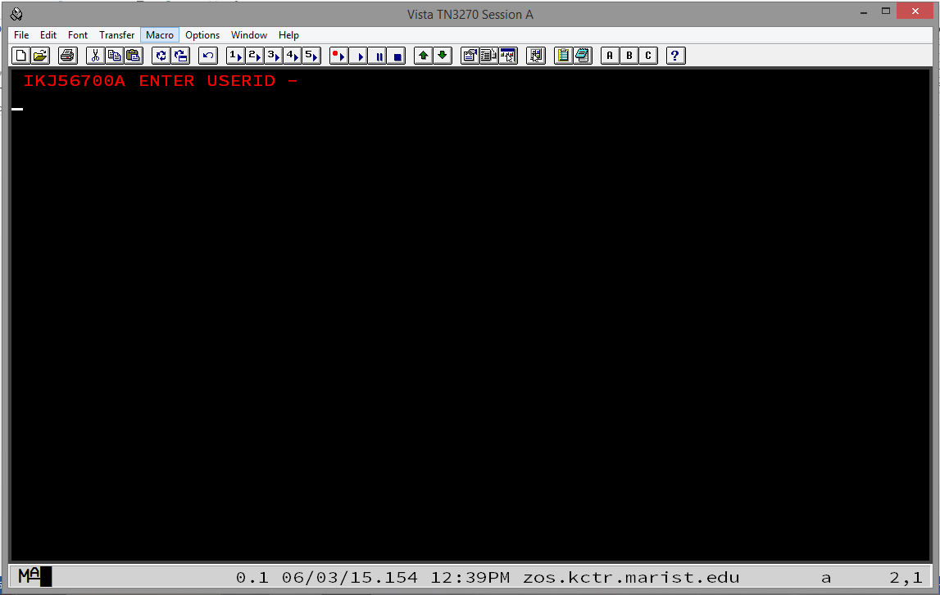

Enter your KC-ID as shown in the following:

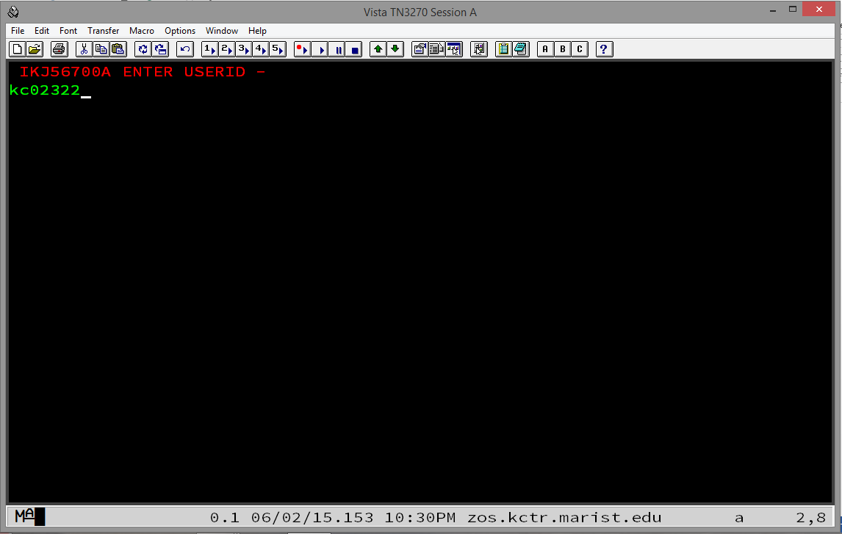

Press Enter and you will be presented the following:

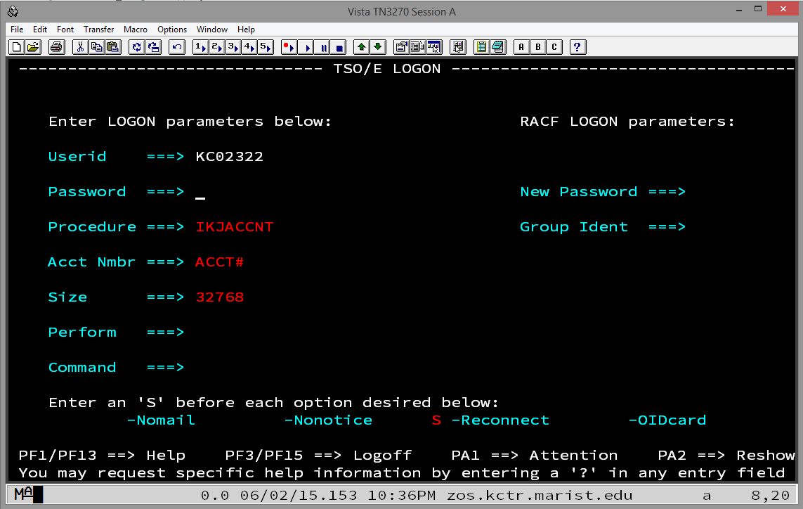

The first time you sign on your password is the same as your KC-ID. Enter it carefully and press Enter. You will be presented the following:

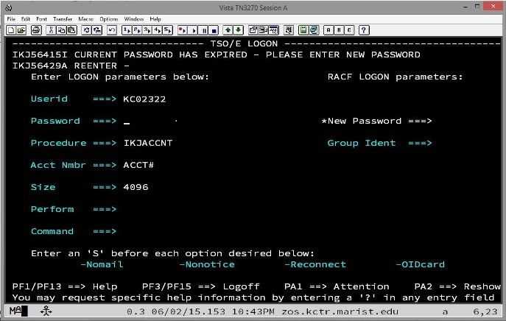

Enter a new password twice and you will be presented the following:

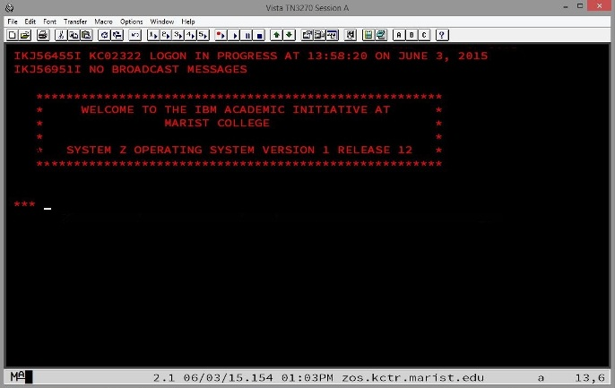

Note that your new password should be eight alphanumeric characters and should begin with a letter. It is NOT case sensitive. Again, you will have to enter it twice. Do so carefully. If you enter an eight-character password, the cursor will automatically tab to where you need to re-enter it to confirm it.

Press Enter again and you will be presented the following, the ISPF (Interactive System Productivity Facility) Primary Option Menu:

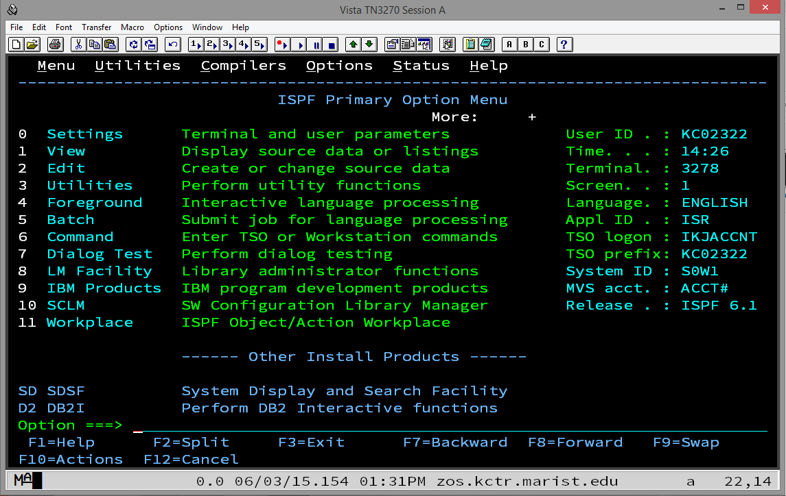

Although this looks complicated, you will only use Options 2 (Edit), 3 (Utilities), and SD (SDSF = System Display and Search Facility) for the remainder of the semester and, if you continue in mainframe studies, in CSCI 465/565 – Enterprise Application Environments.

A PDSE is sometimes called a "library." This is only because a PDSE, unlike a sequential data set, or "flat file," is separated into different members which are, in themselves, sequential files. Each of these members of a PDSE is somewhat like a book on a bookshelf in a library, hence the alias "library." So, a PDSE is a collection of members. You will create a new member for each assignment or other programming exercise this semester. The first one you will create will be named ASSIGN0 but first we need a PDSE to which we will add the member ASSIGN0.

To allocate a PDSE, enter 3 for Utilities and press Enter. You will be presented the following, the Utility Selection Panel:

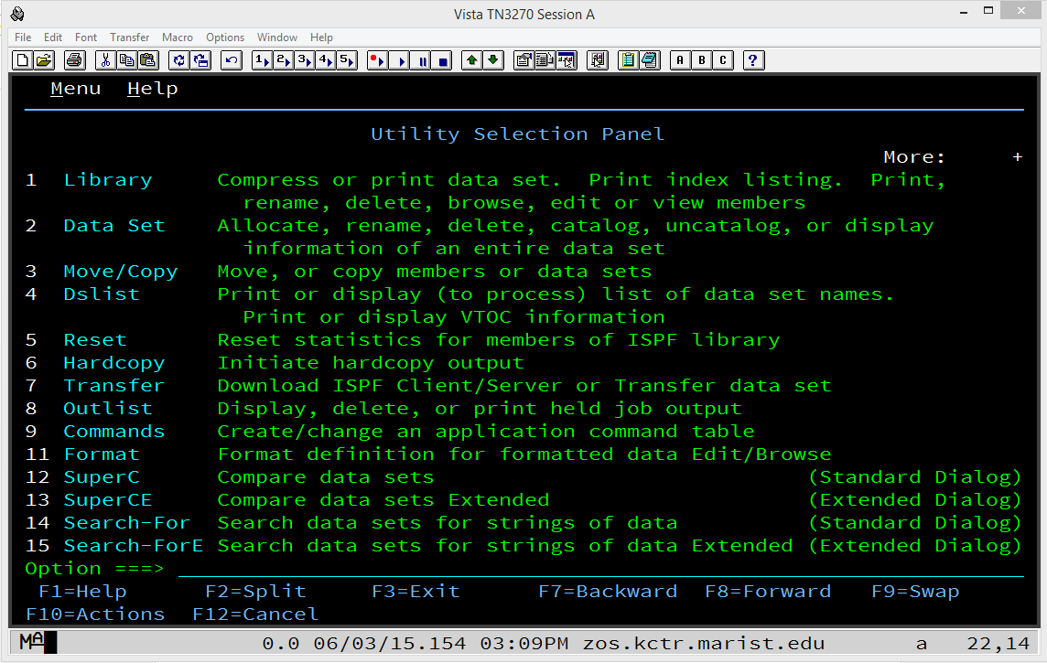

On this screen, enter 2 (Data Set) and press Enter. The first time you enter, you will be presented the following, the Data Set Utility panel:

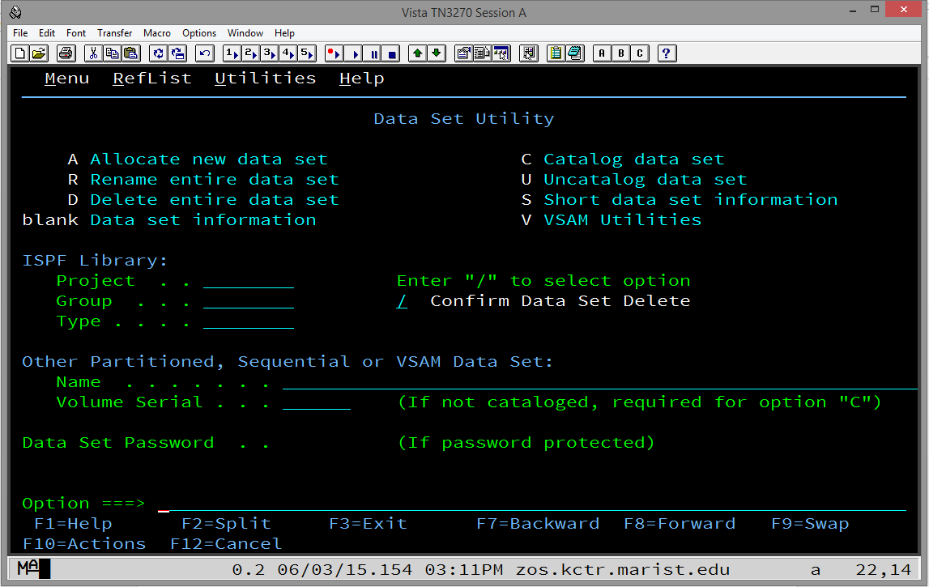

Move the cursor by tabbing or with your mouse to the line to the right of Project under ISPF Library: Type your KC-ID. Tab again to the line to the right of Group and type csci465 (csci565 for graduate students). Tab again to the line to the right of Type and type the word assigns. Tab four times or move the cursor with your mouse to the Option ===> line at the bottom. Enter the letter a (for allocate) and press Enter.

Note that you can enter everything on the ISPF screens as lower case letters and the system will automatically change them to upper case. (This is not necessarily true for the Edit option that will be covered below.)

After pressing Enter, you will be presented the following, the Allocate New Data Set panel:

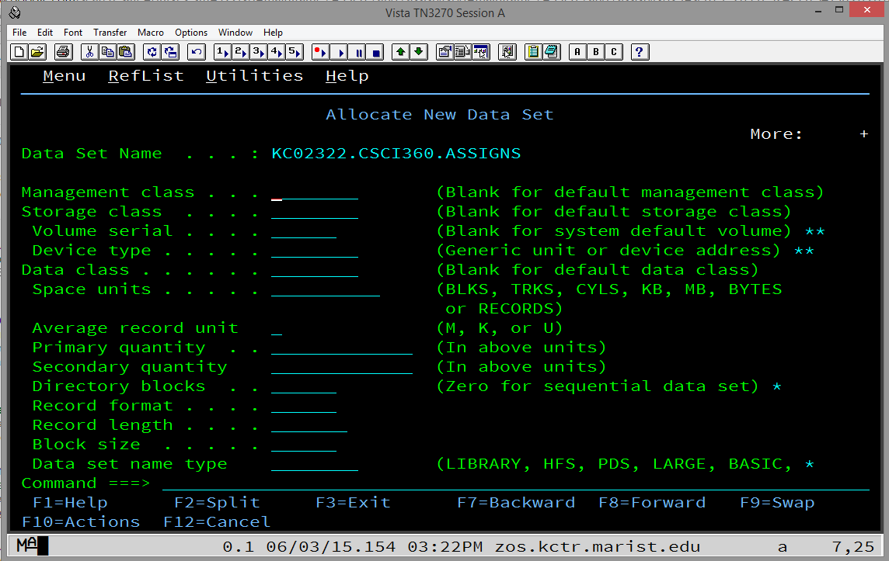

The first time you enter this panel, nothing will be pre-filled. But, the next time, it will be pre-filled with the parameters from the previous time you used this panel, i.e., the last time you successfully allocated a data set.

First, tab or use your mouse to move the cursor to the line to the right of Space units and enter CYLS for cylinders. Tab twice and enter 1 for Primary Quantity. Tab again and enter 1 for Secondary quantity. Tab again and enter 10 for Directory blocks. Tab again and enter FB for Record format. Tab again and enter 80 for Record length. Tab again and enter 880 for Block size. Tab again and enter LIBRARY for Data set name type.

After pressing Enter and, if the data set does not already exist (and it shouldn't!), you will be presented the Data Set Utility panel again with the message Data set allocated in white lettering in the upper right hand corner of the panel:

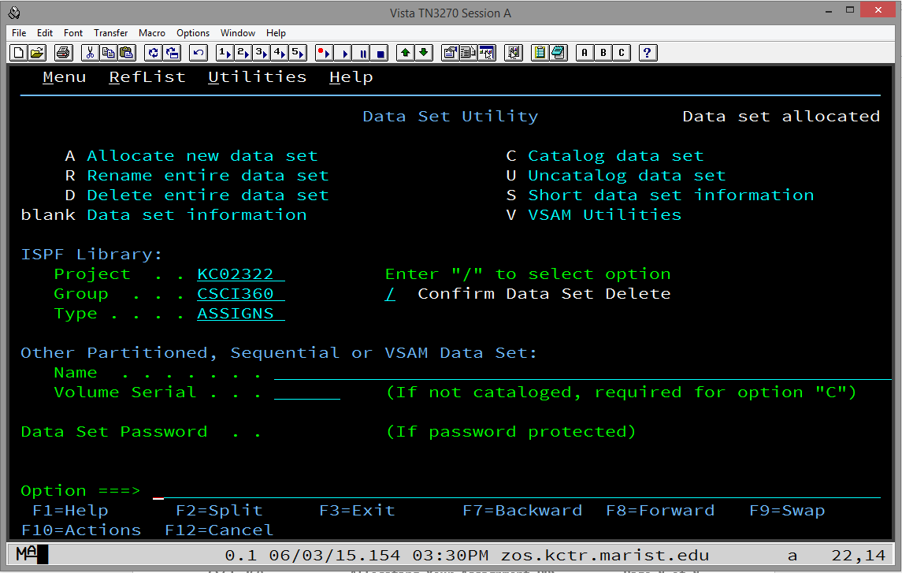

This indicates success! At this point, press F3 twice and you will once again be presented the following:



Now it is time to create and edit your first PDSE member. Enter 2 (Edit) at the Option ===> line and press Enter and you will be presented the following, the Edit Entry Panel:

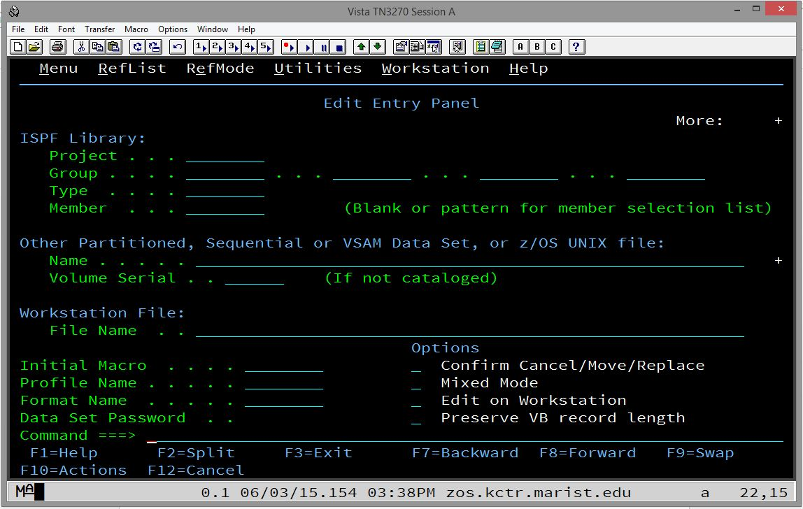

The first time you enter this panel, you will need to fill in some fields that will be pre-filled the next time you come back to it.

Tab a few times or move your cursor with your mouse to the line to the right of Project and enter your KC-ID. Tab once again and enter CSCI465/565 on the line just to the right of Group. Ignore the second, third, and fourth blanks and tab to the line just to the right of Type and enter ASSIGNS.

Finally, tab once more to the line just to the right of Member. It is here that you will enter the name of the member that you want to create and begin editing or you can enter the name of an existing member that you want to return to and continue editing.

At this point, please refer to the document named Editing in ISPF to learn how to edit a new or existing member of your PDSE.

To properly sign off TSO/ISPF, press F3 while in the ISPF Primary Option Menu. If you have made changes while signed on, you will be presented the following screen:

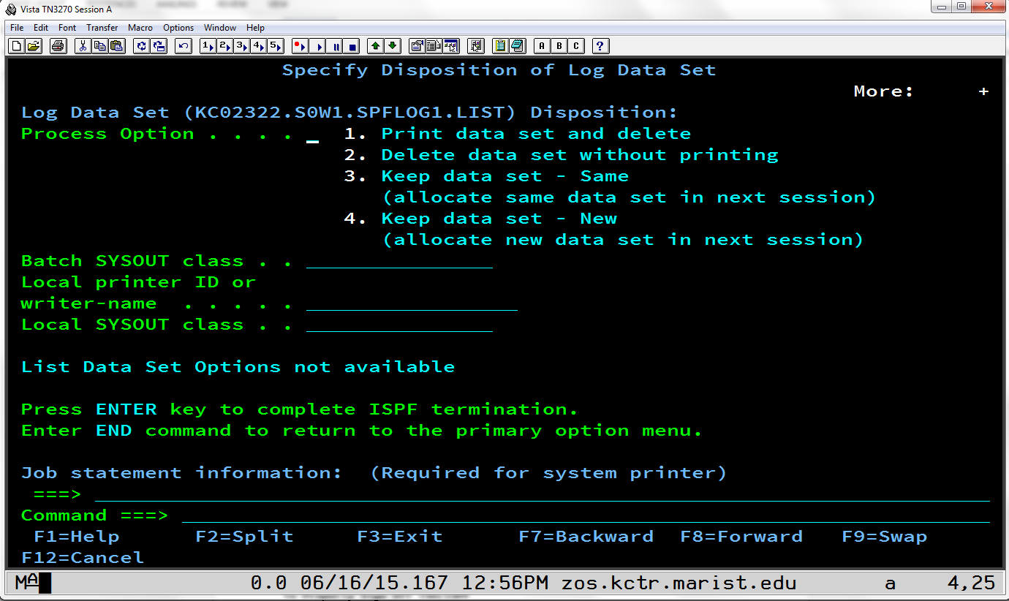

Type the number 2 and press Enter.

You will then be presented a screen with a red-lettered READY displayed as follows:

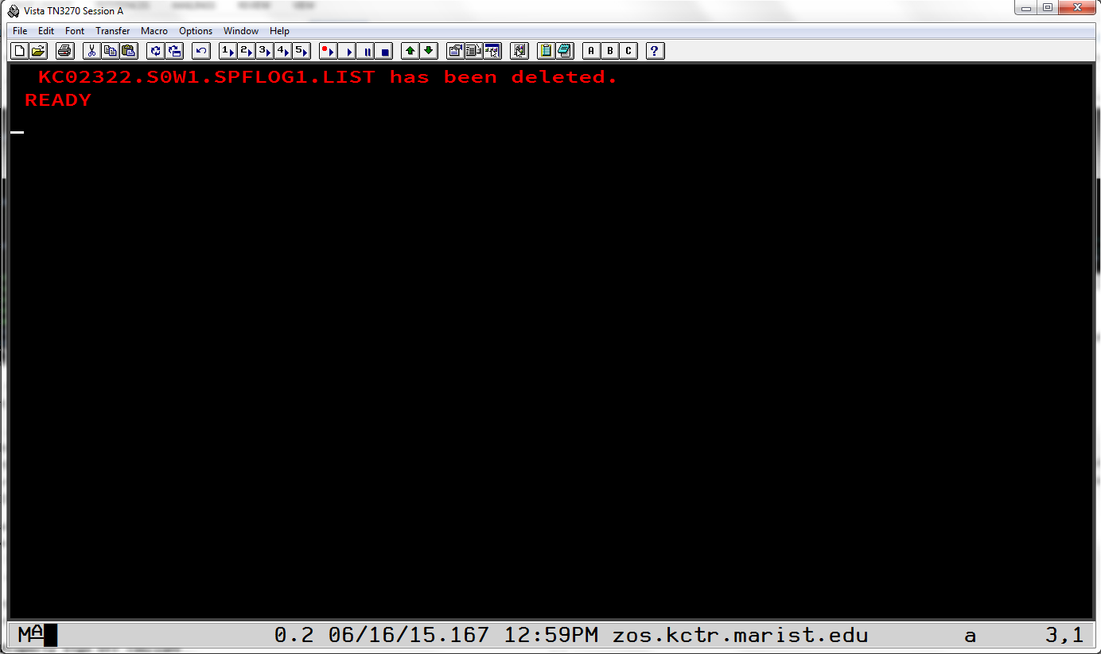

Type the word logoff or LOGOFF and press Enter and you will now be logged off Marist.

**12.2 Editing in ISPF**

It is first important to know that names of entities on the mainframe can have 1 to 8 characters. They can only contain letters A-Z (upper case only), digits 0-9, and international characters $, # and @ (dollar sign, pound sign/hash tag, and at sign). They can only begin with a letter or one of the three international characters. Please do NOT use the international characters in this class (although we will discuss using the $ later).

It is also useful while editing in ISPF to press Caps Lock as 99.9% of everything you type in ISPF will need to be in capital letters.

A) To edit a PDS member:

From the ISPF Primary Option Menu select Option 2 (Edit). Then, on the Edit Entry Panel, type the name of the new member you want want to create and press Enter.

Or to begin editing an already existing member in a PDS:

Follow the same instructions from above or you can press Enter in the Edit Entry Panel and move the cursor to the dot across from the name of the member you wish to edit and type either s, S, e, or E and press Enter.

B) To save a member you are editing:

Type the word save or SAVE anywhere on the command line (Command ===>).

It is recommended that you save the member often as there is no autosave in ISPF!

Please note that items C through G below are usable on most panels in ISPF.

C) To exit a panel:

Use F3 to exit and back up one level.

Be sure that, if you are editing a PDS member, that you save it first!

D) To scroll up and down:

Use F7 for scrolling up and F8 for scrolling down.

E) To scroll left or right:

Use F10 to scroll left and F11 to scroll right.

F) To go to the top or bottom:

Type the word top or TOP on the command line to go to the top of the panel or type the word bot or BOT or bottom or BOTTOM to go to the end.

G) Setting the Scroll ===>:

It is strongly suggested that you change Scroll ===> PAGE to Scroll ===> CSR on every panel that you can in ISPF. ISPF will retain this setting if you exit the panel normally. See lower right hand corner of Figure 1.

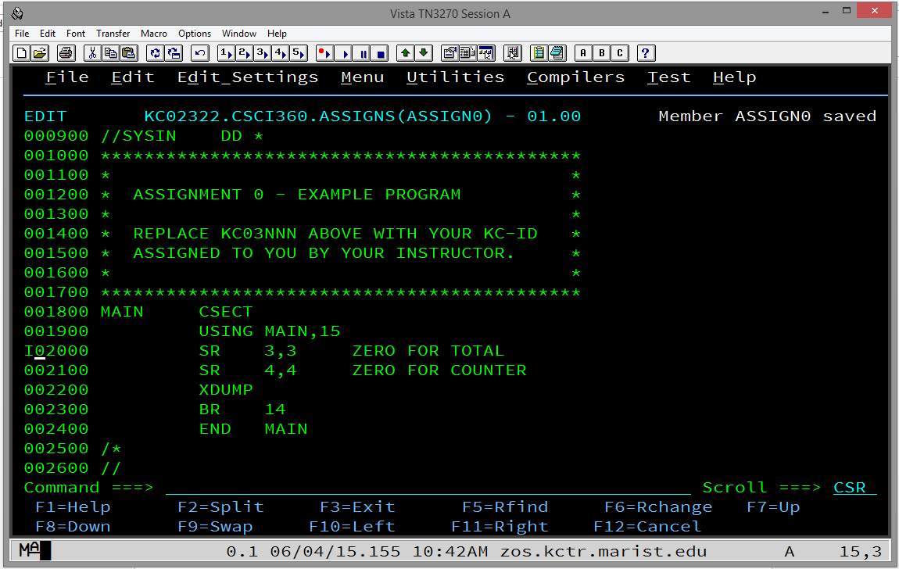

Figure 1.

H) To insert a line while editing:

Move the cursor with the tab key or your mouse to the line numbers on the left hand side of the screen and anywhere within those 6 digits type the letter i or I. See Figure 1. Press Enter to have the line inserted.

See Figure 2.

I) To insert multiple lines while editing:

Do the above but follow the letter i or I with an integer between 2 and n. It will insert the number of lines you have requested but it will not scroll to show all of your inserted lines. It will fit as many on the panel as it can depending on where you began inserting the lines.

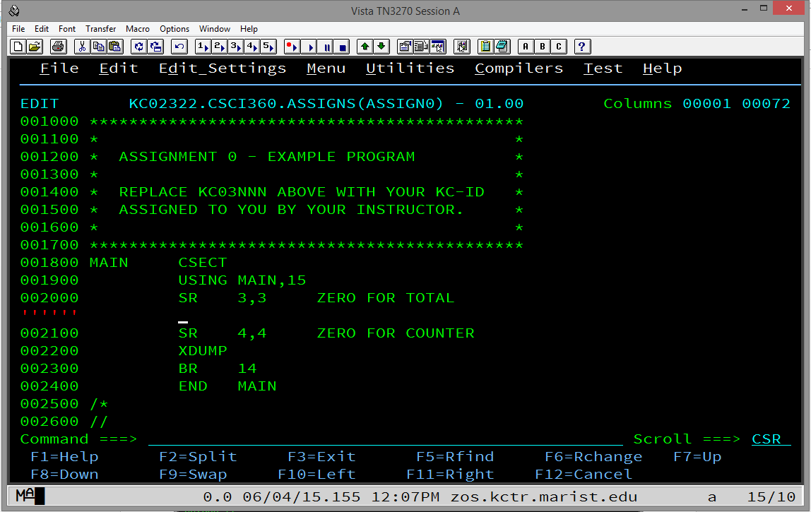

Figure 2.

Note that, if you hit enter at this point, any lines that do not at least have a space (one press of the space bar on your keyboard) will simply be deleted.

Also, if you insert a line and type something on it, a new blank line with be automatically inserted if you press Enter.

J) To delete a line while editing:

Move the cursor with the tab key or your mouse to the line numbers on the left hand side of the screen and anywhere within those 6 digits type the letter d or D. See Figure 3. Press Enter to have the line deleted.

K) To move a line while editing:

Move the cursor with the tab key or your mouse to the line numbers on the left hand side of the screen and anywhere within those 6 digits type the letter m or M. Then, move the cursor with the tab key or your mouse to where you want the line moved and type either a or A for inserting the line you are moving after the line where your cursor is or type either b or B for inserting the line you are moving before the line where your cursor is.

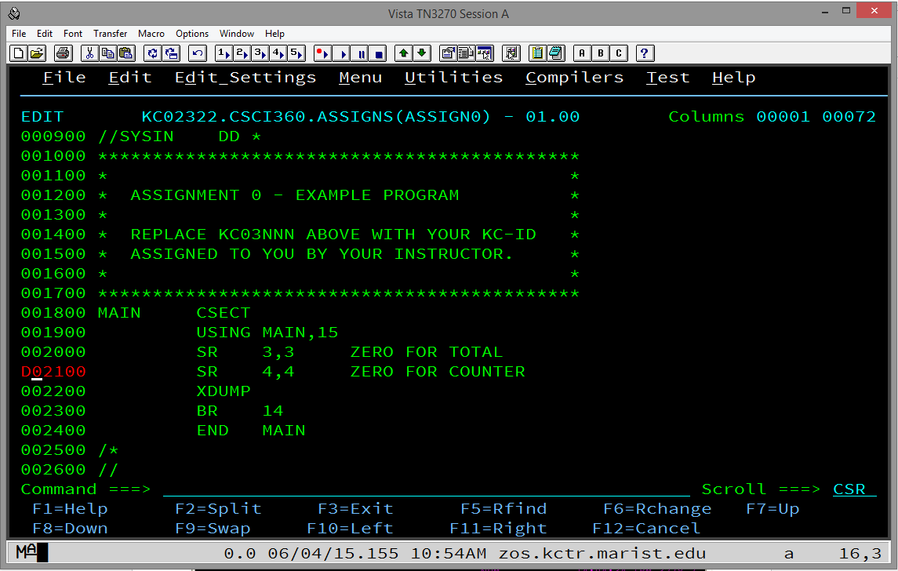

Figure 3.

Note that you can scroll up or down with F7 or F8, respectively, and also use the command line top or bot to go to the top or bottom of the panel while the move is still active.

Also note that, when you start a move, you must complete it before you can go on editing. In other words, if you change your mind, you will still have to move the line but you can then delete it if necessary.

L) To copy a line while enditing:

Move the cursor with the tab key or your mouse to the line numbers on the left hand side of the screen and anywhere within those 6 digits type the letter c or C. Then, move the cursor with the tab key or your mouse to where you want the line copied and type either a or A for inserting the line you are moving after the line where your cursor is or type either b or B for inserting the line you are moving before the line where your cursor is.

M) Deleting, moving or copying blocks, or multiple lines while editing:

To delete a block of contiguous lines, type dd or DD on the first line you want to delete and type dd or DD on the last line you want to delete. These two lines and every line in between will be deleted.

To move a block, use mm or MM on both the first line and the last line you want to move and the a or A for after or b or B for before as in item K above. The block of contiguous lines will be deleted from its   
original place.

To copy a block, use cc or CC on both the first line and the last line you want to copy and the a or A for after or b or B for before as in item K above. The block of contiguous lines will remain in its original place and a copy will be inserted where you indicated it to be inserted.

N) To split a line of text:

To move the end of a line to the next line, or split the text, move the cursor with the tab key or your mouse to the line numbers on the left hand side of the screen and anywhere within those 6 digits type ts or TS for 'text split'. Then, before you press Enter, move your cursor to the character where you want to begin the split. See Figure 4.

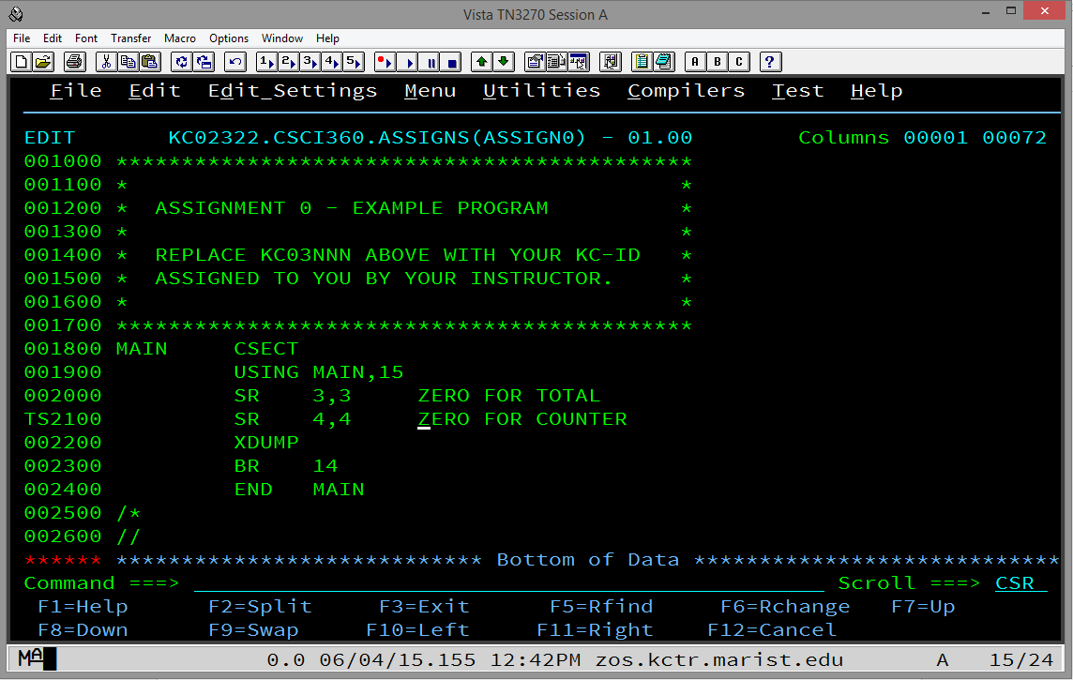

Figure 4.

Now, press Enter. Everything from the character you indicated as the beginning of the split will be pushed and inserted two lines down with a new line inserted in between. See Figure 5. Simply press Enter again and the new blank line will be removed.

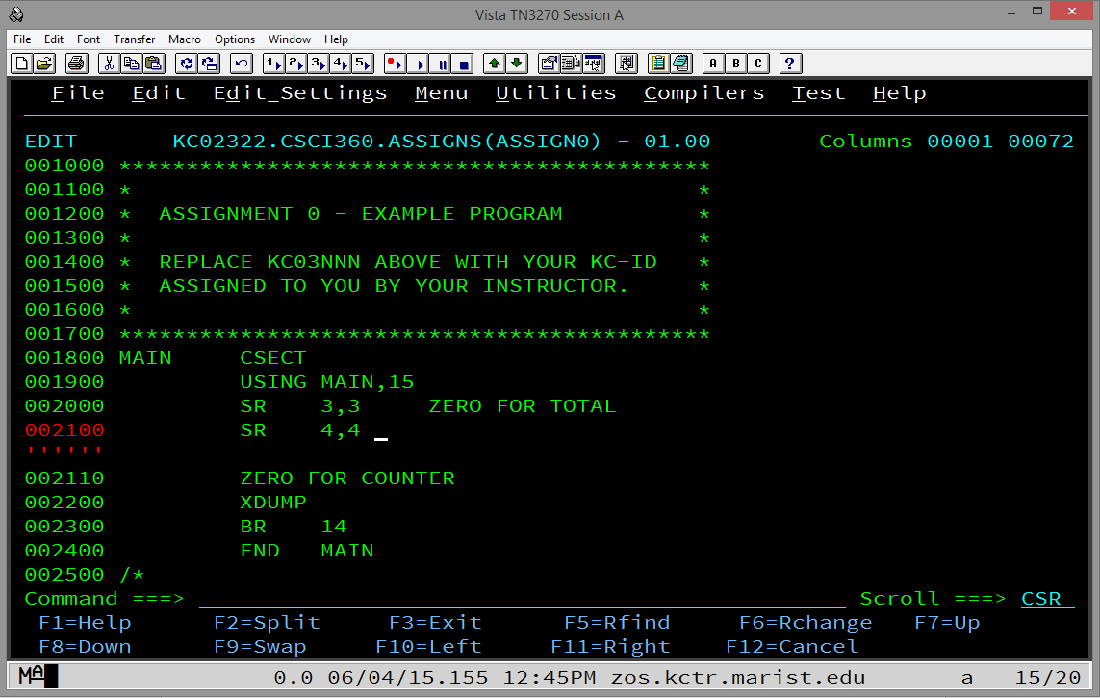

Figure 5.

O) To collapse (hide) lines while editing:

Because it is sometimes scrolling can be frustrating while editing, ISPF allows you to collapse lines. To collapse one or more lines, move the cursor with the tab key or your mouse to the line numbers on the   
left hand side of the screen and anywhere within those 6 digits type x or X to collapse one line or xn or Xn to collapse n lines.

To collapse a block, type xx or XX on the first line you want to collapse and scroll to the last line you want to collapse and type xx or XX. Press Enter and a dashed line will appear telling you how many   
lines are collapsed. See Figure 6.

If you collapse some lines but not enough, you can either type x or X and continue doing it but it is more efficient to move your cursor to the dashed line and type x or X or xn or Xn to collapse another line or another n lines, respectively.

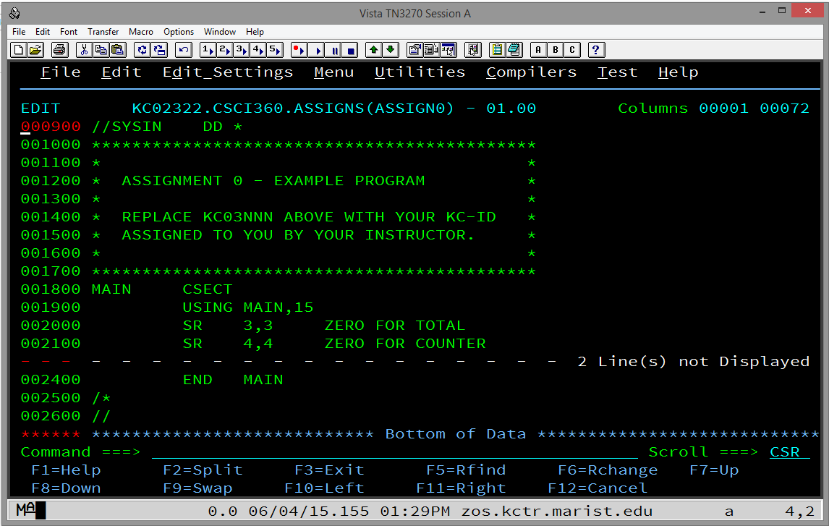

Figure 6.

P) To uncollapse (reveal) lines while editing:

Type res or RES or reset or RESET on the command line and press enter and all of the lines will be uncollapsed or revealed.

To uncollapse or reveal some lines but not others, go to the dashed line and type f or F to reveal the first collapsed line or fn or Fn to reveal the first n collapsed lines. You can also type l or L to reveal   
the last collapsed line or ln or Ln to reveal the last n collapsed lines.

**12.3 Submitting and Viewing Results in ISPF**

To review output in the output queue in SDSF on TSO/ISPF at Marist, enter SD (for SDSF) from the ISPF Primary Option Menu command line. From the SDSF Primary Option Menu enter ST for status on the command line.  This will display the queue of completed jobs, both successful and unsuccessful.

Note that the first time the user comes to this screen, he or she will need to enter OWNER KC03nnn and press enter (KC03nnn represents the user's KC-ID).  This will then only display the user's jobs in the queue.

Be sure not to let these completed jobs pile up. To get rid of jobs in the queue, put a P on the line in the margin just to the left of the job to be purged and press enter.  A P can be entered on multiple jobs at once but the user may have to press enter a few times to get the jobs to roll off.

By the way, the user can enter SD.ST from the ISPF Primary Option Menu to go directly to the status queue.  If somewhere else within TSO, the user can enter =SD.ST to go directly to the status queue. For example, if editing a PDS member and it has been saved, the user can submit his or her job by typing SUB on the command line. A red message will pop up if a successful submission has been made. Press enter again and then enter =SD.ST and press enter to go to the SDSF Status queue to see the results of the recently submitted job.

Once in SDSF status queue, select the job to be reviewed in the queue by typing a letter S in the margin just to the left of the job. It is important to review at least the first few 'pages' of output.  For example, about 8-9 lines down from the top of the job in the queue for Assignment 0 will be similar to the following:

11.22.38 JOB01444 -STEPNAME   PROCSTEP    RC   EXCP   CONN  TCB  SRB   
11.22.38 JOB01444 -JSTEP01                00      7     1  .00  .00

Notice that there is a line with the stepname (JSTEP01 in this example) and, to the right, there is a RC (return code) of 00.  This is a good sign meaning that that step of your job completed successfully.

Scrolling a little further, you will find the following:

IEF142I KC02322A JSTEP01 - STEP WAS EXECUTED - COND CODE 0000

This is another place to check to be sure that the COND CODE (condition code) of each step is 0000 which indicates the step completed successfully.  Of course, there might still be a logic error of some sort but at least that step ran to a successful conclusion.

To submit a file for grading, use mar_ftp.exe to get the file down to your laptop or PC.  It is recommended that the user first download the most recent version of mar_ftp.exe from the Computer Science Department's website.  Put the mar_ftp.exe file in a folder of its own perhaps in the My Documents/Documents library.  Downloaded files from the queue automatically download into the same folder from which mar_ftp.exe is running.

Note that mar_ftp.exe will download two files, one is a .txt file and one is not.  Be sure to open the .txt file and review it carefully from top to bottom before submitting it.  Make sure that nothing is truncated -- especially at the bottom of the file -- and all of the output expected is there.  Submitting a truncated file will earn a 0 so it is very important to be sure it is all there!

Also be sure to keep copies of all of the .txt files that are submitted for assignments.

**12.4 Using mar_ftp.exe to Download Marist Output**

**Overview**

This document offers one of several ways to print jobs that have been run on the Marist mainframe computer.  It is not meant to be comprehensive.

**Instructions**Download mar_ftp.exe and save it into a folder of your choice on your PC:  ["Ftp program for fetching run programs from Marist"](http://www.cs.niu.edu/compresource/mar_ftp.exe)

Follow the mar_ftp.exe instructions to sign onto Marist, fetch the job to be printed, and save it on your PC:  ["Running Instructions"](http://www.cs.niu.edu/compresource/marist_readme.txt)

Once the text file of the Marist job output that is to be printed is saved on your PC, make the following changes to it using, for example, Notepad or Wordpad:  
  
1)  Go to File ---> Page Setup...  
2)  Change Orientation to Landscape and click on OK.  
3)  Go to Format ---> Font...  
4)  Change Font to Source Code Pro, Courier New, Font style to Regular (which is the default), Size to 9, and click on OK.  (It must be 9 to get 133 bytes to fit across the landscape display line.)

Now the text file is ready to print.  Go to File ---> Print... and print your job.

Note:  There are two files saved on your PC.  Be sure that you make the changes to the .txt file.  Once you have printed it, you can delete both files.

**12.5 Using FileZilla to Download Marist Output**

**Allocate an Output Data Set**

1. If you do not have a data set allocated for your output, you will need to do so
   1. To reach the **Data set Utility** screen, enter option **=3.2** from the **ISPF Primary Option Menu**
   2. Under the **ISPF Library** section, fill in the following:
      1. Project – your KC-ID
      2. Group – CSCI465
      3. Type – OUTPUT
   3. Select option **A** to allocate a new data set and press [Enter]

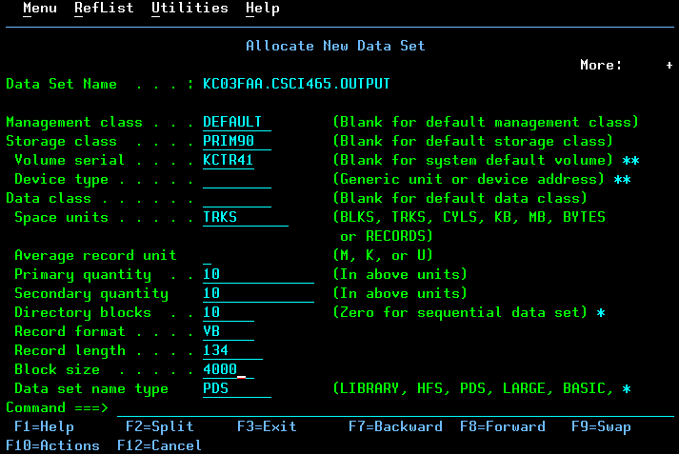

* 1. Allocate your data set with the following properties and press [Enter]
     1. **Space Units** TRKS
     2. **Primary Quantity** 10
     3. **Secondary Quantity** 10
     4. **Directory Blocks** 10
     5. **Record Format** VB
     6. **Record Length** 134
     7. **Block Size** 4000
     8. **Data Set Name Type** PDS
  2. You should now have a data set **KC03nnn.CSCI465.OUTPUT**

**Saving Jobs on the Spool to Output Data set**

1. Once you have run a job, navigate to your output queue with the **=SD.ST** command.
2. Use the **XDC** command next to the output that you want to save

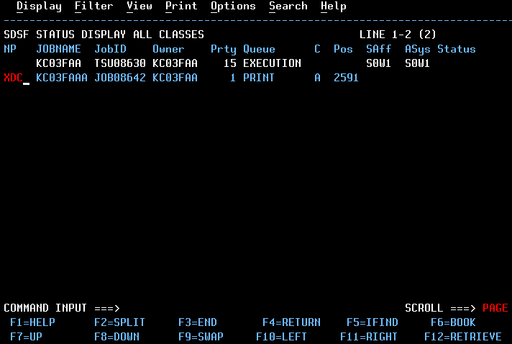

1. You will need to fill out the following fields, and press [Enter]
   1. **Data set name**  'KC03nnn.CSCI465.OUPUT'

Be sure to include the tick marks, and replace KC03nnn with your own KC-ID

* 1. **Member to use** name of the output file
  2. **Disposition** OLD

1. You should now have your output file saved in your output data set. You can verify this by going to the 2nd option from the **ISPF Primary Option Menu** and enter the following information under the **ISPF Library** section:
   1. **Project** KC-ID
   2. **Group** CSCI360
   3. **Type** Name of output data set
   4. **Member** Name of output file that you saved in step 3

**Using FileZilla to Download the Output File**

1. Download FileZilla at the following location & install:

<https://filezilla-project.org/download.php?type=client>

1. Open FileZilla and enter the following fields in the **Quickconnect** toolbar at the top
   1. **Host** zos.kctr.marist.edu
   2. **Username** KC-ID
   3. **Password** KC-ID password
2. Press the **Quickconnect** button
3. Under the ‘Remote Site’ window on the right side, you should see your KC-ID with a plus box next to it. Click on your KC-ID and you should see a list of your data sets (with folder icons to the left) in the window below.

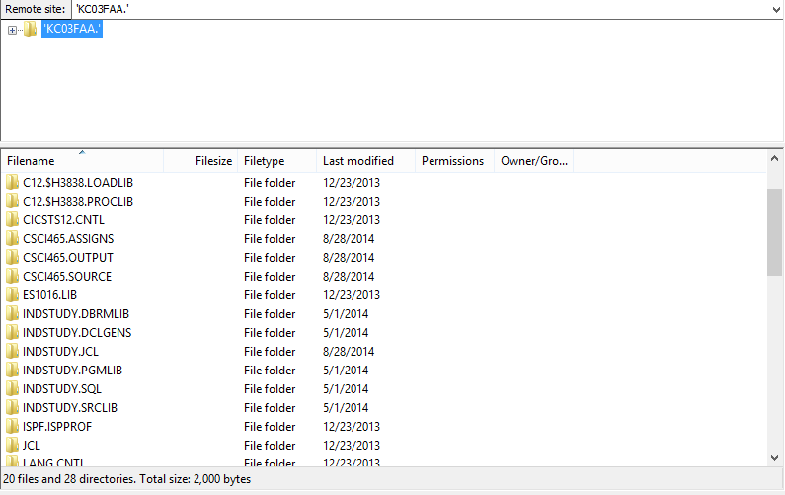

1. Navigate to your output data set in the bottom pane and double click it to open your data set. You should see your output files.
2. You can either drag and drop your output file to a local site, or you can **right click** the file and click **Download** (it will download the file to the Local Site location that is currently selected on the right side

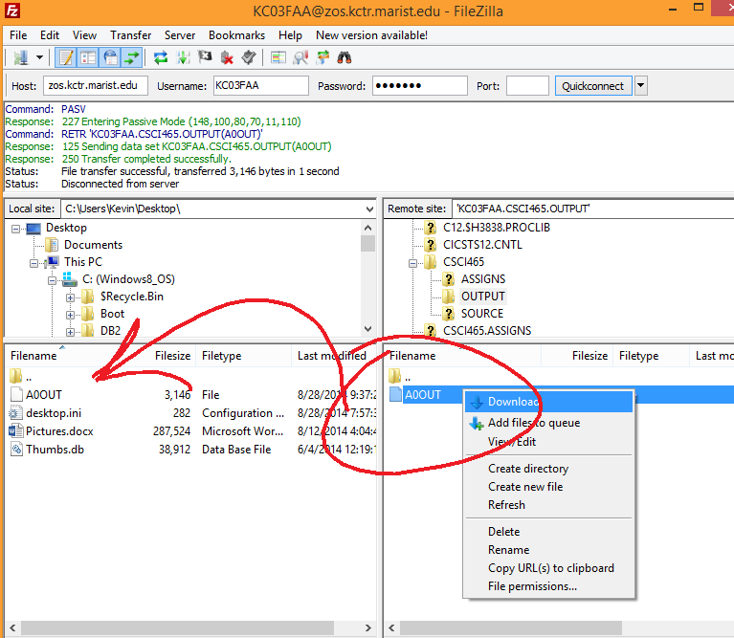

Please noted that there is a very good chance that the report created by your job at the bottom of the .txt file that you have dragged into a folder on your computer is NOT correctly formatted. Open the file with a text editor, change the page layout to landscape and scroll down to the end of the .txt file to make sure you have double-spaced lines as you would expect (if you have double spacing indicated in your mainframe program).

Scroll all the way to the left of the lines that you requested to be double spaced. If you see a number 0 at the beginning of those lines or if you see the number 1 at the beginning of lines that should be at the top of the page, continue on to #7 below.

1. Download the software named format.exe found in the Software Section of Blackboard. To make things simpler, move your .txt file you dragged down from Marist using Filezilla into the same folder you have downloaded format.exe into. Run format.exe, tell it the name of the .txt file you dragged down from Marist and it should properly format the report at the end of the .txt file. Make sure it works, though!

**12.6 Transferring Files to Marist**

**Overview**

This is helpful if you have .txt files or something of the same format that you want to transfer to Marist.  This is not meant to be comprehensive and it is also not meant to be a way for you to avoid using ISPF to edit your homework. Please do not do this on a regular basis.

**Instructions**

Create a PDS at Marist into which you will store the files you transfer there.  Add at least one "junk" member to this PDS.

Using Filezilla or another ftp program, sign onto Marist using the following parameters:

Host:  zos.kctr.marist.edu  
Username:  KCnnnnn        (your user ID at Marist, of course)  
Password:  your Marist password

Let the port number default.

At this point, you should be able to "open" your PDS at Marist and then click and drag files from your PC into your Marist PDS.

**Sometimes the PDS MUST have at least one member in order to click and drag members into it!  
  
Also, it is critical that the transfer type is ASCII and not AUTO or BINARY.  There is a chance that AUTO will work but BINARY will not.  The transfer occurs with any of the three but BINARY gives you unreadable characters in your PDS member when you view it to edit in TSO/ISPF.**

Note:  You will have to remove any file extensions, such as .txt or .jcl, from your files before you click and drag to transfer them to Marist.  The names of these files must be NO longer than eight characters, contain ONLY letters and digits, and must begin with a letter. Also, NO spaces allowed!

**12.7 How to Fix Invalid Characters Found in ISPF**

The following is NOT provided to encourage students to use Notepad, Wordpad or some other editor to write mainframe programs and applications! You should ONLY use TSO/ISPF’s editor!

Students sometimes have problems with invalid characters that cause problems in ISPF. Most invalid characters come from copying data from an outside editor like notepad. One example of this is the ASCII CHAR(10).

In ISPF Edit (Primary Option Menu Option 2), you can issue the command:

FIND P'.'

This will find all characters in the member/dataset that ISPF cannot display. It highlights what looks to be empty spaces and you can issue the following command to fix it:

CHANGE P'.' ' '

This will replace the invalid characters with spaces.

**12.8 Customizing TSO/ISPF**

When you first enter a TSO/ISPF session, you will find that panels display basic IBM defaults. This document covers some optional changes that you can make to customize your TSO/ISPF session. Be careful and do not become too enthusiastic to start. Perhaps it would be best to try a few things before making most or all of the changes suggested here.

Follow the instructions below to modify your screen display. Your new configuration and setup options will automatically be saved when you log off.

**Move the Command Line to the Top of the Screen**

1. Select the "Menu" action bar from the ISPF Primary Menu
2. Select "Settings" from the pull-down menu
3. Set the ISPF settings as follows:

_ Command line at bottom

_ Panel display CUA mode

_ Long message in pop-up

_ Tab to action bar choices

_ Tab to point-and-shoot fields

/ Restore TEST/TRACE options

/ Session Manager mode

/ Jump from leader dots

_ Edit PRINTDS Command

/ Always show split line

1. Press PF3 to exit

Tip: You can also type **Settings** from any screen to bring up the settings panel.

**Remove the PF-Key Display**

1. Select the "Menu" action bar from the ISPF Primary Menu
2. Select "Settings" from the pull-down menu
3. Select Function Keys from Settings action bar
4. Type "6" (Remove function key display)
5. Press Enter
6. Press PF3 to exit

Tip: You can also type PFSHOW from any screen to see Pfkey displays. You can modify your Pfkeys by typing ZKEYS from any screen.

**Remove Underscores on Panels**

1. Select the "Menu" action bar from the ISPF Primary Option Menu
2. Select "Settings" from the pull-down menu
3. Select Colors/CUA Attributes (2) from the Settings action bar
4. Scroll to the next page
5. Modify 'Normal Entry Field" by entering NONE in Highlight column
6. Press PF3 to exit

Tip: You can also type CUAATTR from any panel to go directly to CUA Attributes.

**Display the Calendar**

1. Select the "Status" action bar from the ISPF Primary Option Menu
2. Select Calendar (3) from the pull-down menu
3. Press Enter

All fields on the calendar are point-and-shoot fields that function as follows:

* Click the right bracket ( > ) and the months go forward
* Click the left bracket ( < ) and the months go backwards
* Click the month (e.g. February) and the Calendar Month pop-up lets you specify the month to be displayed
* Click the year (e.g., 1998) and the Calendar Year pop-up lets you specify the year to be displayed
* Click Saturday, Sunday, or Monday to specify the start day for your calendar week
* Click any Day (e.g., Mo, Tu, We) to display the Start-Day pop-up
* Click any number in the month and the Julian Date pop-up displays (but you cannot enter anything in this pop-up)
* Click "Time" to display the pop-up for 12 or 24 hour format
* Click "Day of Year" to translate the Julian Date to a standard date (ccyy/mm/dd)

The colors of the calendar can be changed, for example:

1. Select the Menu action bar.
2. Select Status Area (9) from the list.
3. Select the Options action bar (on the Status Area pop-up).
4. Select Calendar colors (2).
5. Select 2 (Red) for Heading Date and Current Day, then press Enter. You'll see your changes immediately on the sample calendar.
6. After modifying the colors, Press PF3 twice to exit the two pop-ups.
7. You must now exit the Main Menu for your color choices to be displayed. Go to another option and then return to the Main Menu.

**Change the View Entry panel (Option 1) to default to Browse**

1. Type **=1** and press Enter.
2. Scroll or tab down (press PF8).
3. Place a slash (/) in front of the "Browse Mode" option.

**Remove the Warning for Recovery**

The following sequence of commands will set RECOVERY OFF. With recovery set to off, the "UNDO not available" message will not be displayed.

1. Type **=2** and press Enter.
2. Edit any dataset or PDS member.
3. At the Command line type:  **rec off nowarn**
4. Press Enter.

**Set Log/List Defaults**

The Log dataset used by ISPF should be deleted at the end of each session. To delete the log:

1. Select the Menu action bar from the ISPF Primary Option Menu.
2. Select "Settings" from the pull-down list.
3. Select Log/List action bar from ISPF Settings panel.
4. Select "Log Data Set Defaults" (1) and enter:

Process option 2

SYSOUT class A

Local Printer ID blank

Lines per page 60

Primary pages 1

Secondary pages 1

Log Message ID blank

1. PF3 to exit.